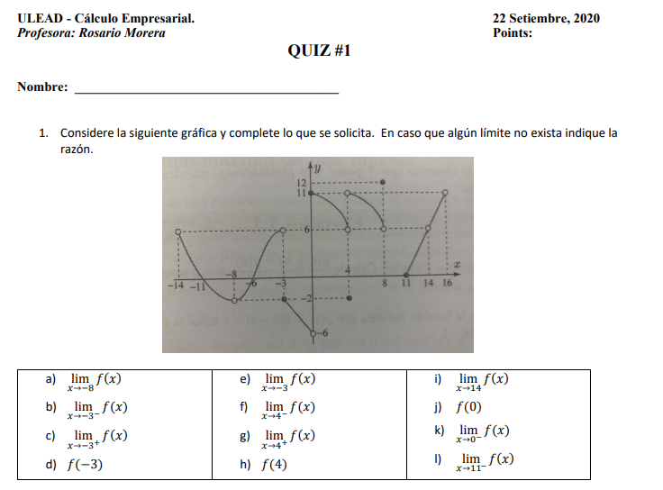

= No existe

= -6

= 11

= 11

= 6

= -2

= 6

= No existe

= -2

= -2

= 6

= -2

Gabriel León Castro

